
MEMORANDUM

To: | Charlie Refvem, Department of Mechanical Engineering, Cal Poly SLO crefvem@calpoly.edu
From: | Colby Cordoba ccordoba@calpoly.edu  Hobbs Hegedus hhegedus@calpoly.edu
Date: | 3-3-2026
RE: | Lab 0x06 - State Estimation

Assignment
In this lab, the goal is to write a new hardware driver for the BNO055 IMU and to develop a state-estimation algorithm that fuses sensor measurements with the Romi model from HW 0x03 to better estimate Romi’s true state.

Part 1: BNO055 IMU Driver
The assignment is designed to be done in two main steps, starting with writing and testing a driver that reads IMU data in a useful form.
The IMU driver supports I2C communication and includes these core features:
- Initialize using a preconfigured pyb.I2C object in CONTROLLER mode
- Change the BNO055 operating mode to a “fusion” mode
- Read and parse the calibration status byte
- Read and save calibration coefficients
- Write saved calibration coefficients back to the IMU
- Read Euler angles
- Read angular velocity
Calibration can be slow, but it improves measurement quality. We implemented a function that saves calibration coefficients, so calibration can be skipped on future startups.

Part 2: State Estimation
The next task was to build a state estimator that combines the Romi model with sensor inputs using a four-state linear model representing Romi’s core linear dynamics, then use an observer to estimate states from:
- Wheel encoder measurements (left/right wheel displacement)
- IMU measurements (heading/yaw angle and heading/yaw rate)
Implementation approach: We implemented the observer in discrete time as
$${\hat{x}}_{k+1}=A_{d}{\hat{x}}_{k}+B_{d}\left[\begin{aligned}u \\ y\end{aligned}\right]$$
- $u=\left[u_{L},u_{R}\right]$(motor commands)
- $y=\left[s_{L},s_{R},ψ,\dot{ψ}\right]$(measured outputs).
- $A_{d}$and $B_{d}$ were precomputed offline (MATLAB c2d() using ZOH) because MicroPython/ulab cannot do matrix exponentials or continuous-discrete conversion on the MCU.
- Instead of ulab. numpy.dot(), we expanded the dot products by hand (scalar multiplies + sums).
- We then used the estimated forward displacement/heading to integrate nonlinear kinematics ($cos⁡,sin⁡$) to predict $x,y$ however because $x,y$are not directly measured, they cannot be corrected by feedback, and will drift over time.
First, here is the description of our previous lab 0x05 control framework and coincident tasks:
- motor_driver.py: low-level motor actuation
  - set_effort(effort) saturates to ±100, sets direction pin, then sets PWM duty percent.
  - enable() brings nSLP high (awake), disable() puts it to sleep.
- encoder.py: wheel sensing (position + velocity)
  - Uses a hardware timer in encoder mode (ENC_AB), and supports invert = to flip sign convention.
  - update() computes dt_us, reads the timer count, corrects wraparound, accumulates position.
  - get_velocity() returns counts/s using delta * 1e6 / dt_us (and applies sign if needed).
- sensor_driver.py: QTR analog line sensor (normalized + centroid)
  - QTRSensorsAnalog: Reads raw ADC (0…4095) and normalizes each channel to 0…1000 based on white/black calibration.
  - Provides centroid-style “Pololu units” position: 0…(N−1)*1000, and line_error() as signed error from center.
- task_read_line(): (defined in main.py) reads normalized sensor values and computes line_err via weighted centroid when signal is strong enough; sets line_ok accordingly.
  - If cal_cmd==1
    - Calibrate white;
  - If cal_cmd==2
    - Calibrate black, then set cal_done=1.
  - If later time permit will restructure for a cleaner main.
- task_motor.py: The wheel task (sensor + controller + actuator + logging)
  - Every cycle (when enabled):
    - Update encoder and publish omega and position shares.
    - Compute effort: If internal PI enabled: reads ref = setpoint.get() (counts/s), runs PI, and writes the computed effort back into the effort share (so the UI can still display it).
    - Apply effort to the motor driver.
    - Log (omega, t_us) into the queues until full; when full it stops logging only.
- task_follow_line.py: Outer-loop steering PI
  - When follow_en==0: it forces symmetric setpoints (spL=spR=v_nom) and publishes dv=0.
  - When follow_en==1:
  - Otherwise it computes:
    - integrate error: dv = kp*err + ki*i_term
    - saturates dv and does simple anti-windup
    - clamps final spL/spR to limits
- task_user.py — two UIs (tuning vs data collection)’
  - Data UI (start_user==1)
    - l/r/b starts collection, waits for queues to fill, then prints CSV rows.
    - x stops motors during collection.
  - Tuning UI (start_user==0)
    - Lets you set wheel gains, v_nom, line gains, calibration, stream status, and (important) includes:
      - n = run motors (live test, no logging/printing)
      - x = stop motors
our Lab 0x05 control framework is still the backbone of our code, but Lab 0x06 layers state estimation on top of it by adding:
- imu_driver.py — BNO055 IMU driver
  - Boot / verify sensor
  - Set operating mode safely (switches through CONFIG mode)
  - Read motion outputs
    - heading(): yaw/heading in degrees (Euler heading, scaled by 1/16°)
    - yaw_rate(): gyro Z in deg/s (scaled by 1/16 dps)
  - Calibration support
    - Read calibration status byte (sys/gyr/acc/mag 0–3)
    - Read/write the 22-byte calibration profile
    - Save/load that 22-byte blob to a file (bno055_calib.bin) so you don’t recalibrate every power cycle
  - Hardware/I2C note
    - Even though the lab spec mentions pyb.I2C, your implementation supports SoftI2C too (via a small adapter), and main.py uses:
    - SCL = PB13, SDA = PB14, address 0x28
- task_imu.py — IMU publisher task
  - From the BNO055 driver it reads:
    - heading (deg)
    - yaw rate (deg/s)
    - calibration byte (raw)
  - Publishes:
    - imu_heading (float share)
    - imu_yawrate (float share)
    - imu_calraw (byte share)
- Runtime commands (via shares, typically written by UI)
  - imu_mode share: lets you change fusion mode at runtime
    - UI toggles IM
    - UPLUS (0x08) and NDOF (0x0C))
    - imu_zero_cmd: when set to 1, the task stores the current heading as an offset and publishes a “zeroed” heading thereafter.
    - imu_save_cmd: when set to 1, saves calibration profile to bno055_calib.bin
    - NOTE: Imu_ driver tries to load calibration from file to skip the long calibration process, and due to data purposes explained later already has a load calibration file.
- task_state_estimator.py — Discrete observer / sensor fusion
  - a discrete-time observer that estimates Romi state using the simplified 4-state model.
  - State vector
    - xhat = [ΩL, ΩR, s, ψ]
    - ΩL, ΩR: wheel angular speeds (model state units)
    - s: forward distance traveled (mm)
    - ψ: heading (rad)
  - Inputs and measurements
    - Wheel displacements from encoder positions:
      - posL, posR are counts
        - converted to mm via: s = r * (counts / counts_per_rad)
    - Motor commands from effort shares:
      - effortL, effortR in [-100, 100]
      - converted to volts: u = effort * (Vbatt/100)
    - IMU heading and yaw rate
      - heading (deg - rad)
      - yaw rate (deg/s - rad/s)
      - optional heading unwrapping to avoid ± π discontinuity
    - Observer math
      - Uses constant hard-coded matrices:
        - x[k+1] = A*x[k] + B*[uL, uR, sL, sR, ψ, ψdot]
        - Those matrices are produced offline in Lab0x06_Matlab.m:
      - Builds the continuous model (A, B, C)
      - chooses observer poles (place)
      - forms (A − L*C) and [B, L]
      - discretizes with c2d to generate A_d and B_d
  - Outputs
    - xhat_s (estimated distance, mm)
    - xhat_psi (estimated heading, rad)
    - x_pos, y_pos (dead-reckoned pose in mm, integrated from ds and ψ)
    - dist_traveled (same as s)
    - estimated wheel speeds xhat_omegaL, xhat_omega
    - predicted measurement outputs yhat_* for debugging
- task_tuning_ui.py — New unified UI
  - We removed the user_task in Lab 0x06 because we were running into serious MicroPython memory issues after adding the IMU + state estimator.
  - The Data UI was “heavy” because it:
    - Used logging queues (lots of stored data in RAM),
    - Big CSV print dumps (large temporary strings/allocations),
    - Extra menu/state logic.
  - With the new Lab 0x06 modules, that extra RAM use caused MemoryError/crashes/unstable runs, so we simplified to a single lighter Tuning UI.
Table 1 showcases how our code is organized across multiple files.
Table 1: Task, Periods, and Priorities
Task Name (scheduler) | Task Object / Function | Priority | Period (ms) | What it does (1-line)
Left Motor | leftMotorTask.run | 1 | 20 | Updates left encoder, runs internal PI (setpoint→effort), drives left motor (logging disabled in this build)
Right Motor | rightMotorTask.run | 1 | 20 | Updates right encoder, runs internal PI (setpoint→effort), drives right motor (logging disabled in this build)
Line Read | task_read_line | 3 | 20 | Reads QTR sensors, computes line_err (centroid), handles white/black calibration via cal_cmd/cal_done
Line Follow | followTask.run | 3 | 20 | Outer PI steering: uses line_err → computes dv → writes setpointL/setpointR, publishes dv_out
IMU | imuTask.run | 2 | 20 | Reads BNO055 heading + yaw rate + cal byte; supports mode/zero/save-cal commands; can load calib from bno055_calib.bin
State Estimator | estTask.run | 2 | 20 | Discrete observer: fuses encoders + motor efforts + IMU to estimate xhat_s, xhat_psi and dead-reckoned x_pos/y_pos

The state estimator performed well and produced physically reasonable estimates for all states in the estimated state vector xhat. The estimated wheel angular velocities converged accurately during straight-line motion and separated correctly during turning. The estimated linear displacement increased consistently as the robot moved forward and remained nearly constant during in-place rotation, confirming that the encoder data were consistent with the system model. The estimated heading closely tracked the IMU measurement while avoiding discontinuities, demonstrating that the observer successfully incorporated angular rate and heading feedback to correct drift.
Although the global position (x, y) was not directly part of the observer state, it was reconstructed by integrating the estimated displacement and heading. When the robot followed the 600 mm circular path, the internally generated position plot (as generated by our step collector loop code from lab 0x05) showed a consistent circular trajectory matching the circle's diameter (somewhat), as shown in Figure 1.
Figure 1. Estimated Coordinates
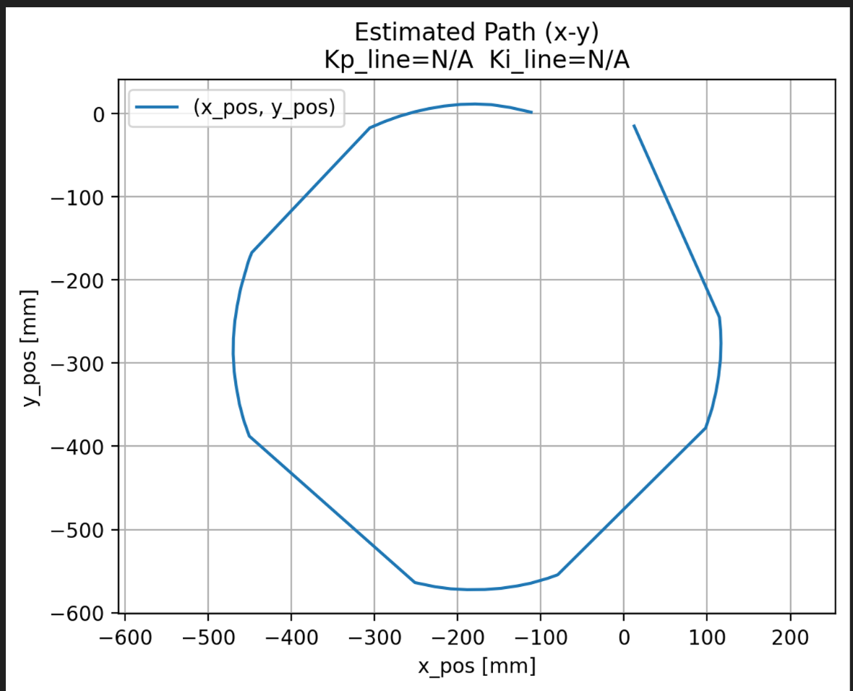
This result indicates that the estimator effectively fused encoder and IMU measurements to maintain an accurate pose estimate over time. While the graphed circle is not a perfect representation of the path overall, the robot reliably tracked its position, demonstrating successful completion of our state estimation.
Figure 2 is our task diagram, and Figure 3 is our block diagram, both of which depict the overall structure of our program. Figure 4 contains multiple finite state machines for our individual task files, and Figure 5 contains our finite state machines from the last lab for reference.

Figure 2. Task Diagram
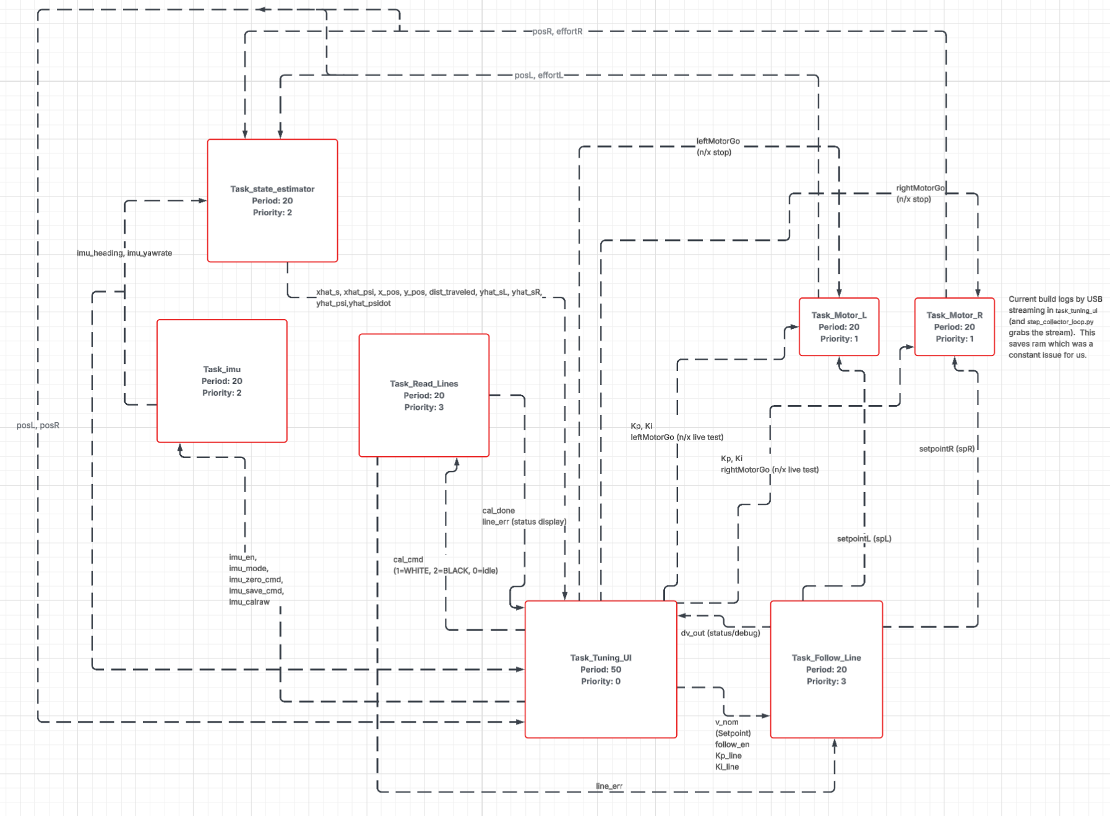
Figure 3. Block Diagram
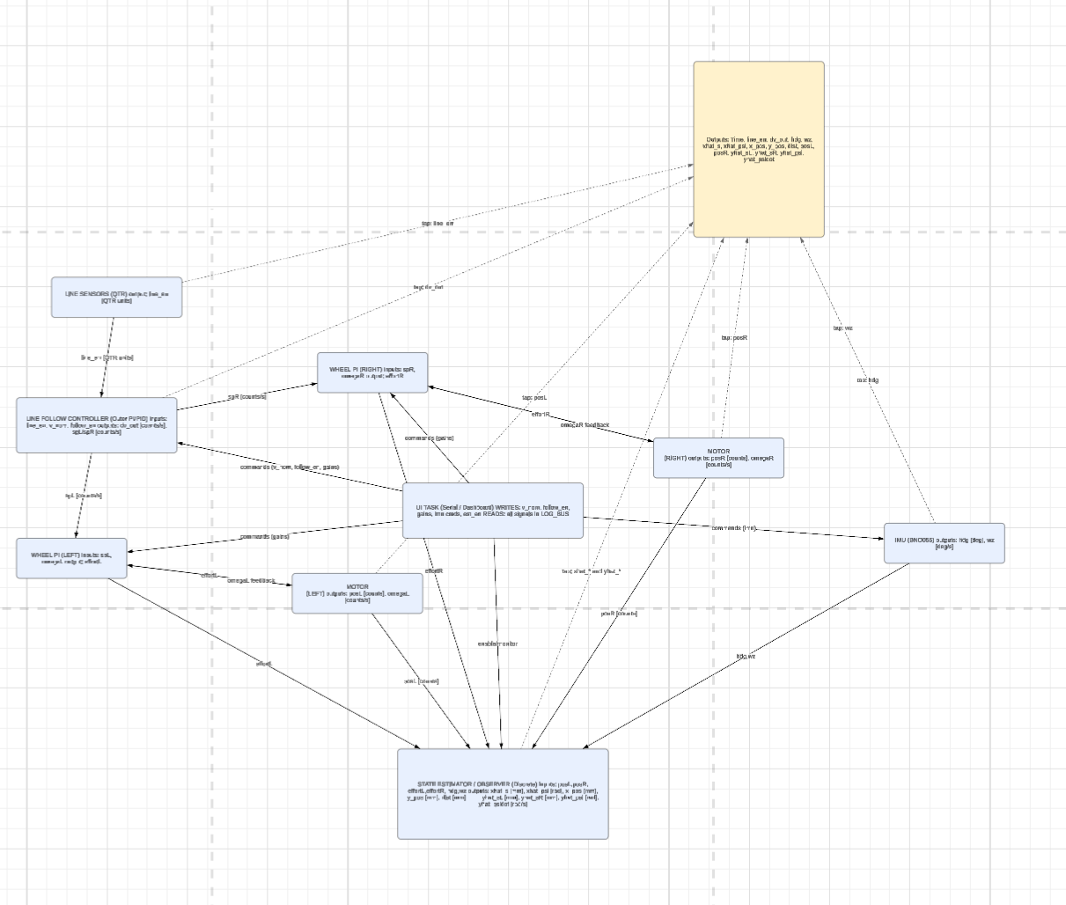
Figure 4. New Finite State Machines
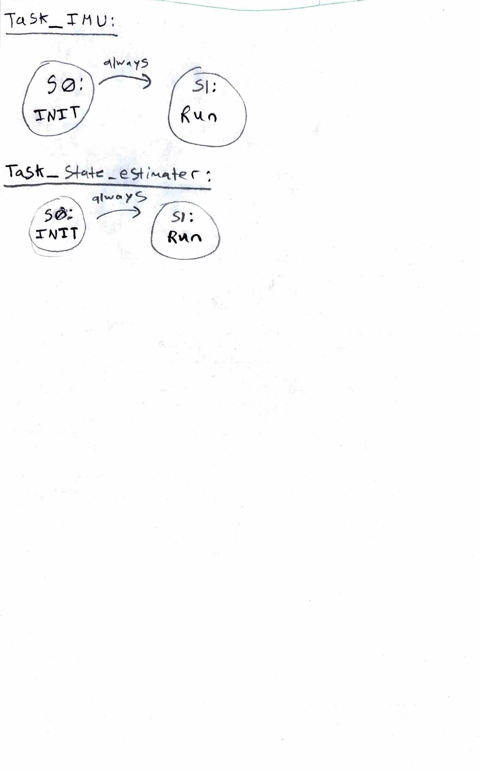

Figure 5. Lab 0x05 Finite State Machines
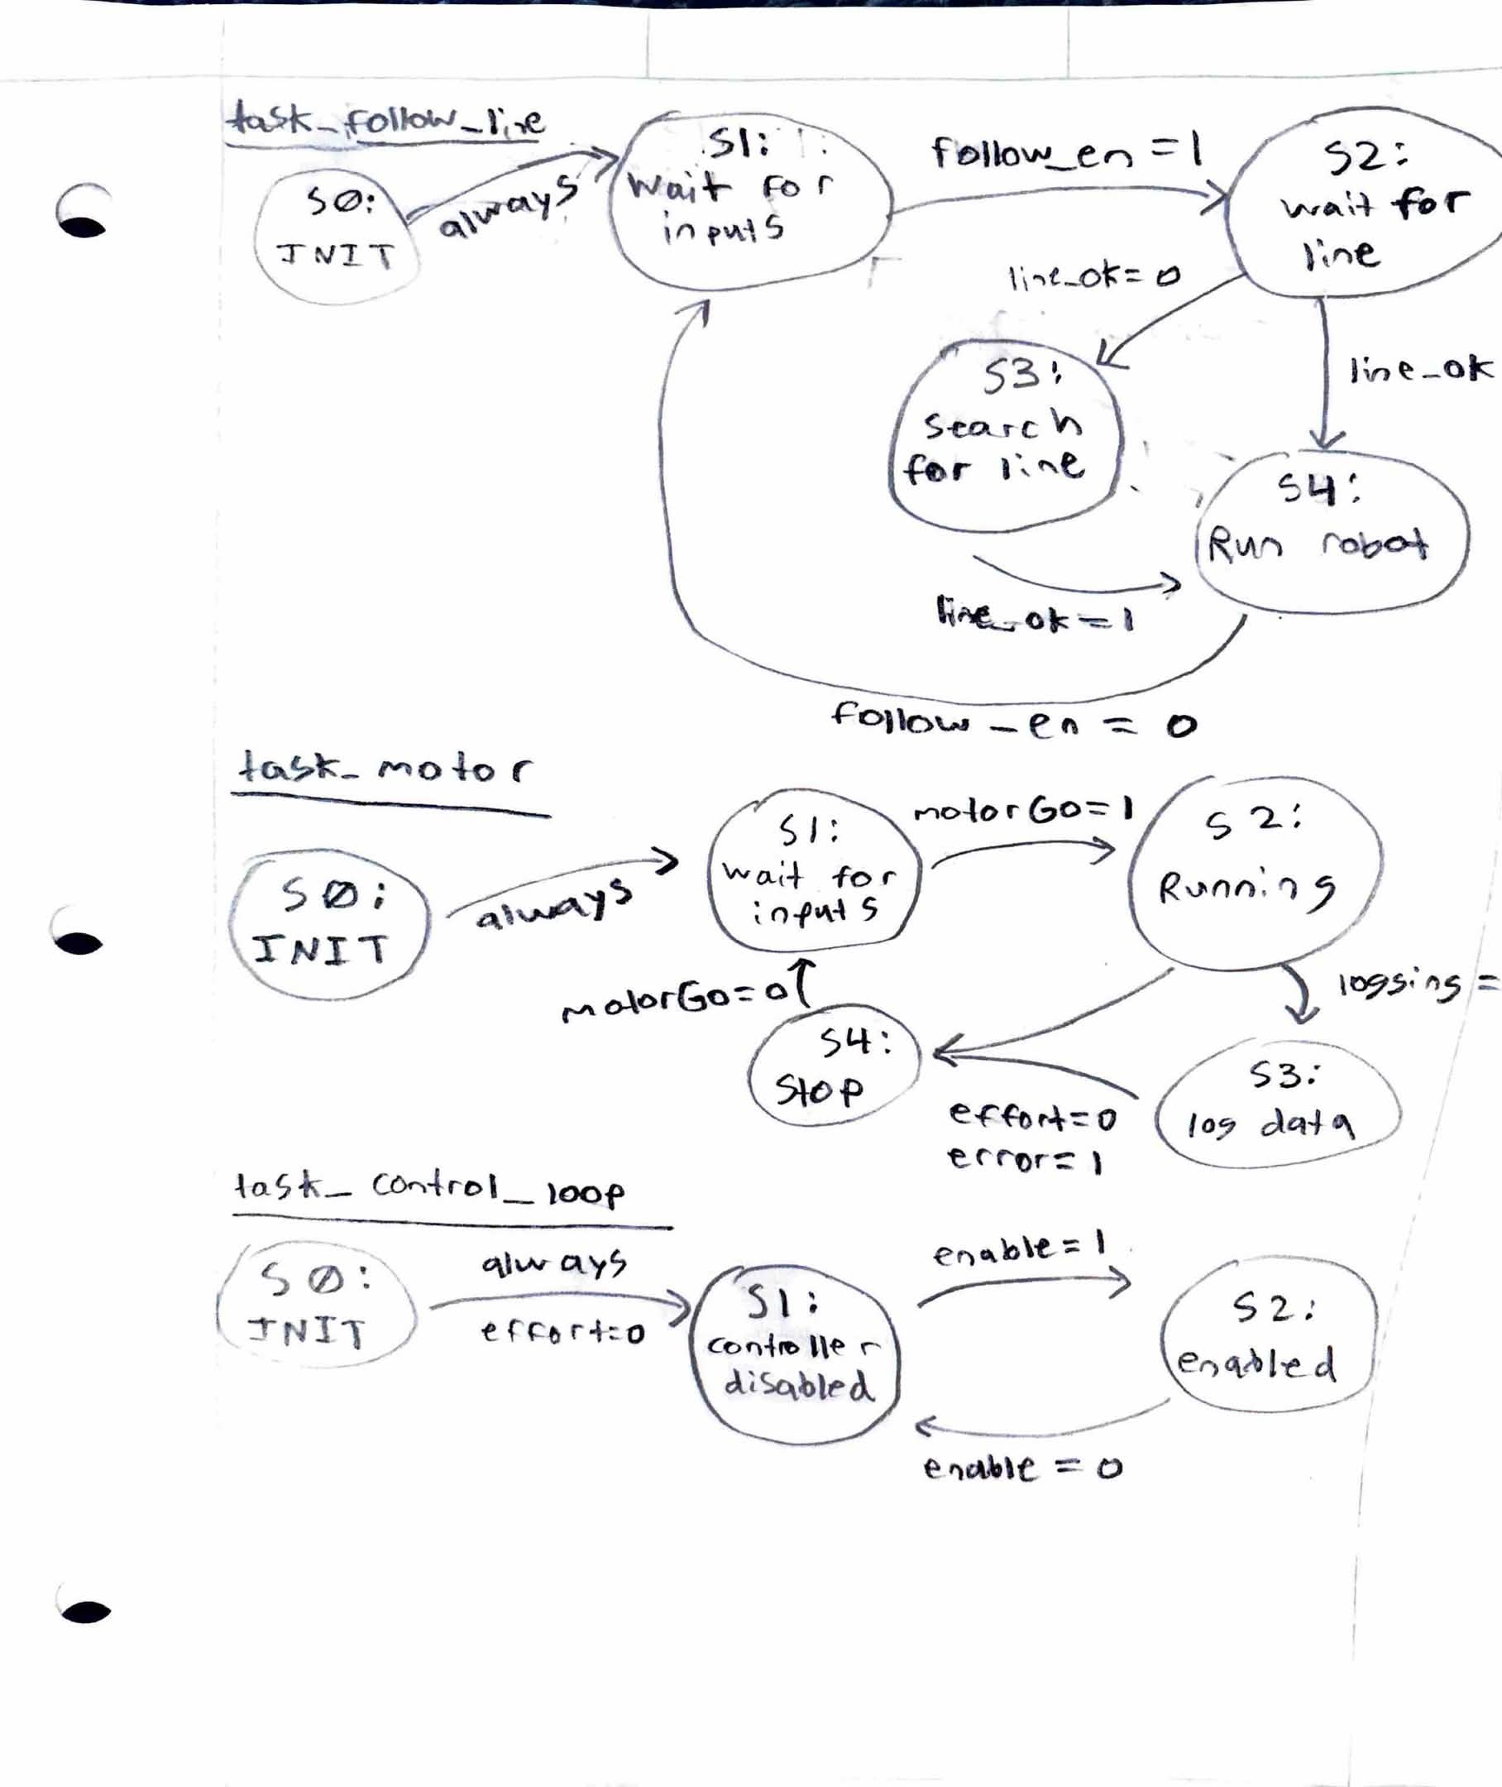

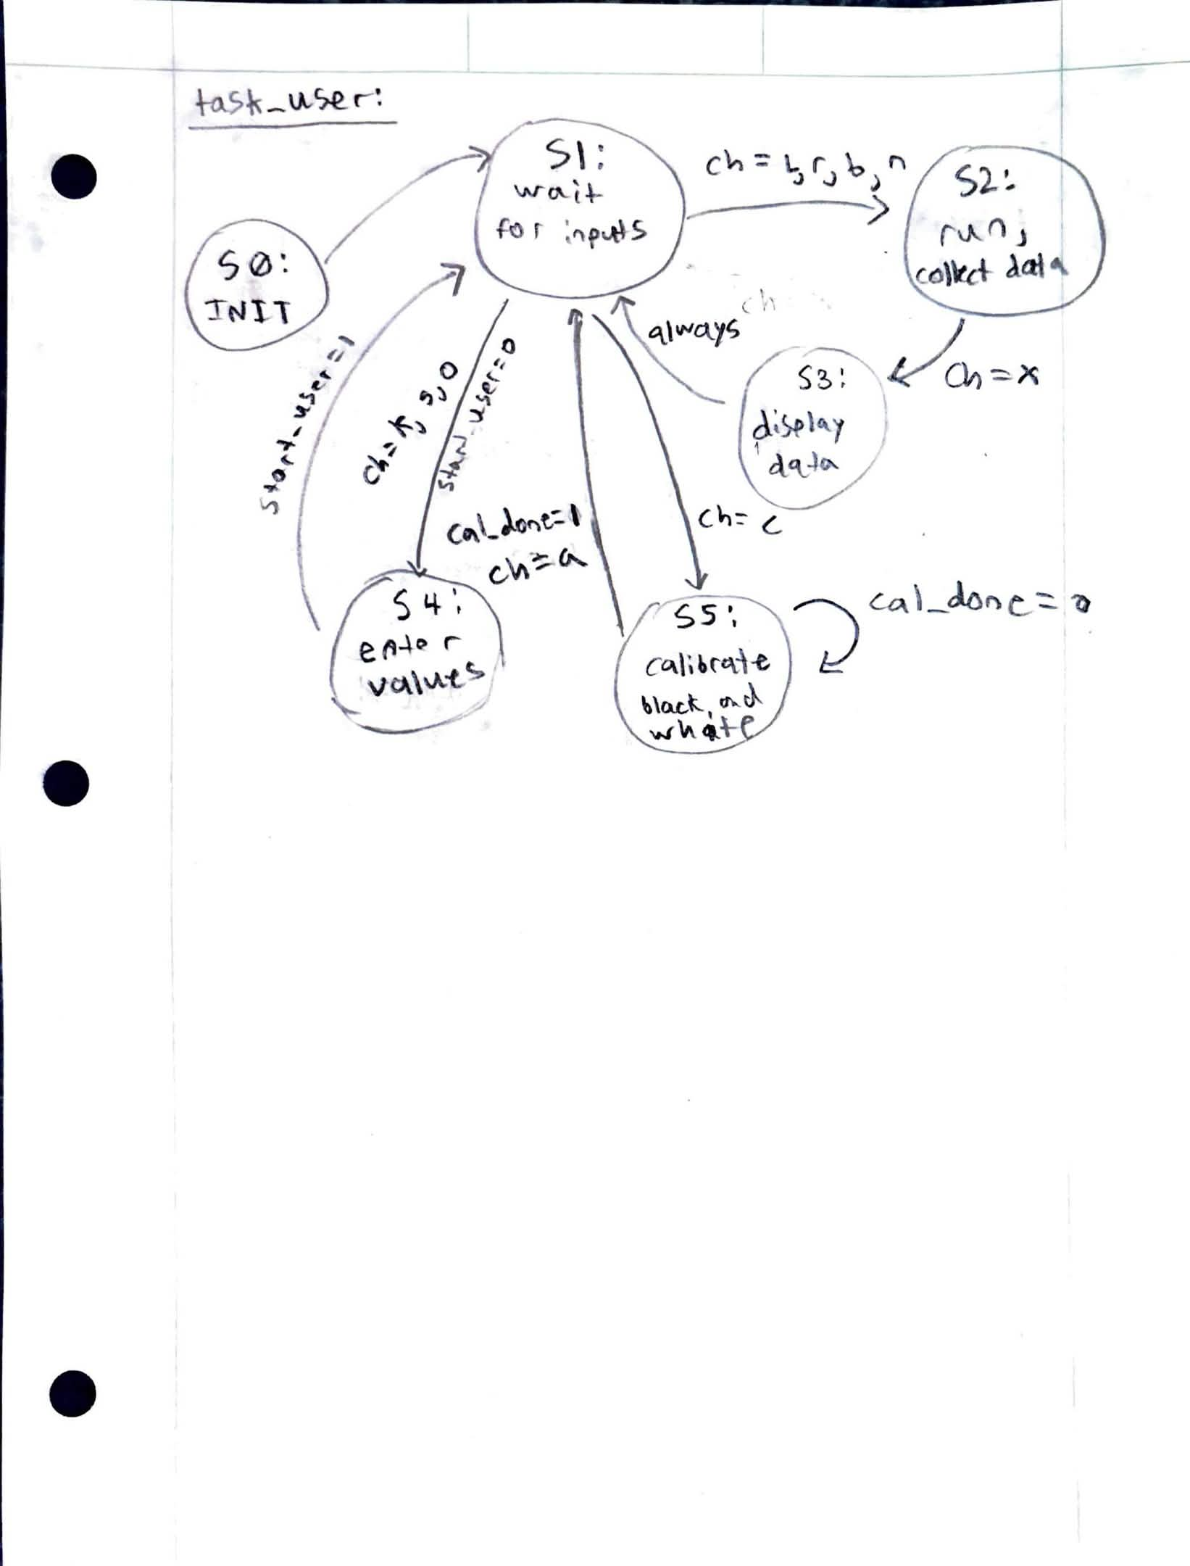
References:
- Source Files:
  - cotask.py
  - encoder.py
  - main.py
  - imu_driver.py
  - motor_driver.py
  - sensor_driver.py
  - step_collector_loop.py
  - task_follow_line.py
  - task_imu.py
  - task_motor.py
  - task_share.py
  - task_user.py
  - task_state_estimator.py
  - task_tuning_ui.py
  - ui_help.py

Transcript of Modified code files:
- MATLAB code:
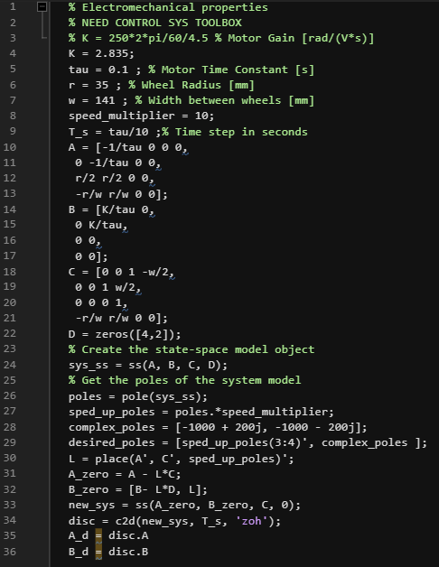
  - Imu_driver:
# imu_driver.py
  - # MicroPython BNO055 IMU driver (pyb.I2C):

  - import time
  - import ustruct

  - try:
  - from machine import SoftI2C, Pin
  - except Exception:
  - SoftI2C = None
  - Pin = None

  - class _I2CAdapter:
  - """Wrap machine.SoftI2C to look like pyb.I2C for this driver."""
  - def __init__(self, i2c):
  - self._i2c = i2c

  - def mem_write(self, data, addr, reg, timeout=0):
  - if isinstance(data, int):
  - data = bytes([data & 0xFF])
  - self._i2c.writeto_mem(addr, reg, data)

  - def mem_read(self, n, addr, reg, timeout=0):
  - return self._i2c.readfrom_mem(addr, reg, n)

  - class BNO055:
  - ADDR_A = 0x28
  - ADDR_B = 0x29

  - # Registers
  - REG_CHIP_ID = 0x00
  - REG_OPR_MODE = 0x3D
  - REG_PWR_MODE = 0x3E
  - REG_SYS_TRIGGER = 0x3F
  - REG_UNIT_SEL = 0x3B
  - REG_CALIB_STAT = 0x35

  - # Data registers
  - REG_EULER_H_LSB = 0x1A # heading (yaw)
  - REG_GYR_X_LSB = 0x14 # gyro x,y,z

  - # Calibration profile storage region
  - REG_CALIB_START = 0x55
  - CALIB_LEN = 22

  - # Power modes
  - PWR_NORMAL = 0x00

  - # Operation modes
  - MODE_CONFIG = 0x00
  - MODE_IMUPLUS = 0x08 # accel + gyro fusion (no mag) - often best indoors
  - MODE_NDOF = 0x0C # full fusion (accel+gyro+mag)

  - def __init__(self, i2c, addr=ADDR_A, timeout_ms=50):
  - """
  - i2c: pyb.I2C object already configured in CONTROLLER mode.
  - """
  - self.i2c = i2c
  - self.addr = addr
  - self.timeout_ms = timeout_ms
  - self._mode = self.MODE_CONFIG

  - # Confirm chip ID (BNO055 can boot slowly)
  - chip = self._read_u8(self.REG_CHIP_ID)
  - if chip != 0xA0:
  - time.sleep_ms(700)
  - chip = self._read_u8(self.REG_CHIP_ID)
  - if chip != 0xA0:
  - raise OSError("BNO055 not found (CHIP_ID=0x%02X)" % chip)

  - # Start in CONFIG
  - self.set_mode(self.MODE_CONFIG)

  - # Normal power
  - self._write_u8(self.REG_PWR_MODE, self.PWR_NORMAL)
  - time.sleep_ms(10)

  - # Leave UNIT_SEL default (Euler deg, gyro dps)
  - # self._write_u8(self.REG_UNIT_SEL, 0x00)

  - # Clear SYS_TRIGGER
  - self._write_u8(self.REG_SYS_TRIGGER, 0x00)
  - time.sleep_ms(10)

  - # ---------- low-level helpers ----------
  - def _write_u8(self, reg, val):
  - self.i2c.mem_write(val & 0xFF, self.addr, reg, timeout=self.timeout_ms)

  - def _read_u8(self, reg):
  - return self.i2c.mem_read(1, self.addr, reg, timeout=self.timeout_ms)[0]

  - def _read_len(self, reg, n):
  - return self.i2c.mem_read(n, self.addr, reg, timeout=self.timeout_ms)

  - # ---------- required lab methods ----------
  - def set_mode(self, mode):
  - """Safely switch operating mode (switch through CONFIG)."""
  - if mode == self._mode:
  - return

  - # go CONFIG first
  - self._write_u8(self.REG_OPR_MODE, self.MODE_CONFIG)
  - time.sleep_ms(25)

  - # set target
  - self._write_u8(self.REG_OPR_MODE, mode & 0xFF)
  - time.sleep_ms(25)

  - self._mode = mode

  - def get_calib_status(self):
  - """
  - Returns dict with sys/gyr/acc/mag each 0..3 and raw byte.
  - """
  - cs = self._read_u8(self.REG_CALIB_STAT)
  - return {
  - "sys": (cs >> 6) & 0x03,
  - "gyr": (cs >> 4) & 0x03,
  - "acc": (cs >> 2) & 0x03,
  - "mag": (cs >> 0) & 0x03,
  - "raw": cs,
  - }

  - def get_calib_coeffs(self):
  - """Read 22 bytes calibration profile (do in CONFIG mode)."""
  - prev = self._mode
  - self.set_mode(self.MODE_CONFIG)
  - data = self._read_len(self.REG_CALIB_START, self.CALIB_LEN)
  - self.set_mode(prev)
  - return bytes(data)

  - def set_calib_coeffs(self, data):
  - """Write 22 bytes calibration profile (do in CONFIG mode)."""
  - if data is None or len(data) != self.CALIB_LEN:
  - raise ValueError("Calibration data must be %d bytes" % self.CALIB_LEN)

  - prev = self._mode
  - self.set_mode(self.MODE_CONFIG)
  - self.i2c.mem_write(data, self.addr, self.REG_CALIB_START, timeout=self.timeout_ms)
  - self.set_mode(prev)
  - time.sleep_ms(10)

  - def read_euler(self):
  - """
  - Returns (heading_deg, roll_deg, pitch_deg).
  - Scale: 1 LSB = 1/16 degree (default).
  - """
  - buf = self._read_len(self.REG_EULER_H_LSB, 6)
  - h, r, p = ustruct.unpack("<hhh", buf)
  - return (h / 16.0, r / 16.0, p / 16.0)

  - def heading(self):
  - return self.read_euler()[0]

  - def read_gyro(self):
  - """
  - Returns (gx_dps, gy_dps, gz_dps).
  - Scale: 1 LSB = 1/16 dps (default).
  - """
  - buf = self._read_len(self.REG_GYR_X_LSB, 6)
  - gx, gy, gz = ustruct.unpack("<hhh", buf)
  - return (gx / 16.0, gy / 16.0, gz / 16.0)

  - def yaw_rate(self):
  - return self.read_gyro()[2]

  - def get_calib_raw(self):
  - """Return the raw CALIB_STAT byte (no dict allocation)."""
  - return self._read_u8(self.REG_CALIB_STAT)

  - @classmethod
  - def from_softi2c(cls, scl_pin, sda_pin, freq=100000, addr=ADDR_A, timeout_ms=50):
  - if SoftI2C is None or Pin is None:
  - raise RuntimeError("SoftI2C not available in this MicroPython build")
  - soft = SoftI2C(scl=Pin(scl_pin), sda=Pin(sda_pin), freq=freq)
  - return cls(_I2CAdapter(soft), addr=addr, timeout_ms=timeout_ms)

  - # ---------- convenient file helpers ----------
  - def save_calib_to_file(self, filename="bno055_calib.bin"):
  - data = self.get_calib_coeffs()
  - with open(filename, "wb") as f:
  - f.write(data)

  - def load_calib_from_file(self, filename="bno055_calib.bin"):
  - try:
  - with open(filename, "rb") as f:
  - data = f.read()
  - if len(data) != self.CALIB_LEN:
  - return False
  - self.set_calib_coeffs(data)
  - return True
  - except OSError:
  - return False

Task_user:
import micropython
import pyb
from pyb import USB_VCP
from task_share import Share, Queue

# ---------------- FSM States for data UI ----------------
S0_INIT = micropython.const(0)
S1_CMD = micropython.const(1)
S2_COL = micropython.const(2)
S3_DIS = micropython.const(3)

# ---------------- Modes for data UI ----------------
MODE_NONE = micropython.const(0)
MODE_L = micropython.const(1)
MODE_R = micropython.const(2)
MODE_BOTH = micropython.const(3)

UI_prompt = ">: "

class task_user:
# Data-collection UI task (runs only when start_user == 1)

def __init__(self,
start_user,
leftMotorGo, rightMotorGo,
dataValuesL, timeValuesL,
dataValuesR, timeValuesR,
setpoint, Kp, Ki,
ser=None,
follow_en=None,
Kp_line=None,
Ki_line=None,
line_err=None,
dv_out=None,
print_live_en=None,
# --- IMU shares ---
imu_heading=None, # Share("f") heading deg
imu_yawrate=None, # Share("f") yaw rate dps
imu_calraw=None): # Share("B") raw calib byte

self._state = S0_INIT

self._start_user = start_user
self._leftMotorGo = leftMotorGo
self._rightMotorGo = rightMotorGo

self._ser = ser if ser is not None else USB_VCP()

# Buffers
self._dataL = dataValuesL
self._timeL = timeValuesL
self._dataR = dataValuesR
self._timeR = timeValuesR

# Inner-loop shares (printed for header)
self._setpoint = setpoint # v_nom
self._Kp = Kp
self._Ki = Ki

# Outer-loop shares
self._follow_en = follow_en
self._Kp_line = Kp_line
self._Ki_line = Ki_line
self._line_err = line_err
self._dv_out = dv_out

# IMU shares
self._imu_heading = imu_heading
self._imu_yawrate = imu_yawrate
self._imu_calraw = imu_calraw

# Live printing gate (motor/control tasks must read this)
self._print_live_en = print_live_en

self._mode = MODE_NONE
self._both_phase = 0 # 0=print left, 1=print right

self._ser.write(b"task_user instantiated\r\n")

# ---------------- Printing helpers ----------------

def _print_gains_header(self):
s = self._ser
s.write(b"--------------------------------------------------------------------------------\r\n")
s.write(("V_nom (setpoint): {}\r\n".format(self._setpoint.get())).encode())
s.write(("Wheel Kp: {}\r\n".format(self._Kp.get())).encode())
s.write(("Wheel Ki: {}\r\n".format(self._Ki.get())).encode())

if (self._follow_en is not None) and (self._Kp_line is not None) and (self._Ki_line is not None):
s.write(("Follow_en: {}\r\n".format(int(self._follow_en.get()))).encode())
s.write(("Line Kp: {}\r\n".format(self._Kp_line.get())).encode())
s.write(("Line Ki: {}\r\n".format(self._Ki_line.get())).encode())

if (self._line_err is not None) and (self._dv_out is not None):
s.write(("Line err: {}\r\n".format(self._line_err.get())).encode())
s.write(("dv_out: {}\r\n".format(self._dv_out.get())).encode())

# IMU values
if (self._imu_heading is not None) and (self._imu_yawrate is not None):
s.write(("IMU heading: {}\r\n".format(self._imu_heading.get())).encode())
s.write(("IMU yaw_rate: {}\r\n".format(self._imu_yawrate.get())).encode())
if self._imu_calraw is not None:
s.write(("IMU cal raw: 0x{:02X}\r\n".format(int(self._imu_calraw.get()) & 0xFF)).encode())

if self._print_live_en is not None:
s.write(("Live print: {}\r\n".format(int(self._print_live_en.get()))).encode())

s.write(b"--------------------------------------------------------------------------------\r\n")

def _print_footer_and_prompt(self):
s = self._ser
s.write(b"--------------------------------------------------------------------------------\r\n")
s.write(b"Commands: l=left, r=right, b=both, x=stop, v=toggle live print, h=menu\r\n")
s.write(UI_prompt.encode())

def _print_section_header(self, label):
s = self._ser
s.write(b"Data collection complete...\r\nPrinting data...\r\n")
s.write(b"--------------------------------------------------------------------------------\r\n")
s.write((label + "\r\n").encode())
s.write(b"Time [us], Data\r\n")

# ---------------- Start modes ----------------

def _start_left(self):
self._dataL.clear(); self._timeL.clear()
self._leftMotorGo.put(True)
self._rightMotorGo.put(False)
self._mode = MODE_L
self._print_gains_header()
self._ser.write(b"Starting LEFT data collection...\r\n(press x to stop)\r\nPlease wait...\r\n")

def _start_right(self):
self._dataR.clear(); self._timeR.clear()
self._rightMotorGo.put(True)
self._leftMotorGo.put(False)
self._mode = MODE_R
self._print_gains_header()
self._ser.write(b"Starting RIGHT data collection...\r\n(press x to stop)\r\nPlease wait...\r\n")

def _start_both(self):
self._dataL.clear(); self._timeL.clear()
self._dataR.clear(); self._timeR.clear()
self._leftMotorGo.put(True)
self._rightMotorGo.put(True)
self._mode = MODE_BOTH
self._both_phase = 0
self._print_gains_header()
self._ser.write(b"Starting BOTH data collection (simultaneous)...\r\n(press x to stop)\r\nPlease wait...\r\n")

def _stop_all(self):
self._leftMotorGo.put(False)
self._rightMotorGo.put(False)
self._mode = MODE_NONE

# ---------------- Main FSM ----------------

def run(self):
while True:

# Only active when start_user == 1
if self._start_user.get() == 0:
self._state = S0_INIT
yield
continue

if self._state == S0_INIT:
s = self._ser
s.write(b"\r\nUser task active.\r\n")
s.write(b"Commands: l=left, r=right, b=both, x=stop, v=toggle live print, h=menu\r\n")
if self._print_live_en is not None:
s.write(("Live print: {}\r\n".format(int(self._print_live_en.get()))).encode())
s.write(UI_prompt.encode())

self._mode = MODE_NONE
self._both_phase = 0
self._state = S1_CMD

elif self._state == S1_CMD:
if self._ser.any():
ch = self._ser.read(1).decode()

if ch in ("l", "L"):
self._ser.write((ch + "\r\n").encode())
self._start_left()
self._state = S2_COL

elif ch in ("r", "R"):
self._ser.write((ch + "\r\n").encode())
self._start_right()
self._state = S2_COL

elif ch in ("b", "B"):
self._ser.write((ch + "\r\n").encode())
self._start_both()
self._state = S2_COL

elif ch in ("x", "X"):
self._stop_all()
self._ser.write(b"Stopping...\r\n")
self._ser.write(UI_prompt.encode())

elif ch in ("v", "V"):
self._ser.write((ch + "\r\n").encode())
if self._print_live_en is None:
self._ser.write(b"print_live_en share not wired in main.py\r\n")
self._ser.write(UI_prompt.encode())
else:
try:
left_running = bool(self._leftMotorGo.get())
except Exception:
left_running = False
try:
right_running = bool(self._rightMotorGo.get())
except Exception:
right_running = False

if left_running or right_running:
self._ser.write(b"Cannot toggle live printing while motors are running/collecting.\r\n")
self._ser.write(b"Stop motors (press 'x') first, then toggle.\r\n")
self._ser.write(UI_prompt.encode())
else:
newv = 0 if int(self._print_live_en.get()) else 1
self._print_live_en.put(newv)
self._ser.write(("Live printing set to {}\r\n".format(newv)).encode())
self._ser.write(UI_prompt.encode())

elif ch in ("h", "H"):
self._stop_all()
self._ser.write(b"Returning to tuning menu...\r\n")
self._start_user.put(0)
self._state = S0_INIT

elif self._state == S2_COL:
if self._ser.any():
ch = self._ser.read(1).decode()
if ch in ("x", "X"):
self._stop_all()
self._ser.write(b"\r\nStopped.\r\n")
self._ser.write(UI_prompt.encode())
self._state = S1_CMD
yield
continue

if self._mode == MODE_L:
if self._dataL.full() or self._timeL.full():
self._leftMotorGo.put(False)
self._print_section_header("LEFT DATA")
self._state = S3_DIS

elif self._mode == MODE_R:
if self._dataR.full() or self._timeR.full():
self._rightMotorGo.put(False)
self._print_section_header("RIGHT DATA")
self._state = S3_DIS

elif self._mode == MODE_BOTH:
if (self._dataL.full() or self._timeL.full() or
self._dataR.full() or self._timeR.full()):
self._leftMotorGo.put(False)
self._rightMotorGo.put(False)
self._both_phase = 0
self._print_section_header("LEFT DATA")
self._state = S3_DIS

elif self._state == S3_DIS:
if self._mode == MODE_L:
if self._dataL.any():
self._ser.write("{},{}\r\n".format(self._timeL.get(), self._dataL.get()).encode())
else:
self._print_footer_and_prompt()
self._mode = MODE_NONE
self._state = S1_CMD

elif self._mode == MODE_R:
if self._dataR.any():
self._ser.write("{},{}\r\n".format(self._timeR.get(), self._dataR.get()).encode())
else:
self._print_footer_and_prompt()
self._mode = MODE_NONE
self._state = S1_CMD

elif self._mode == MODE_BOTH:
if self._both_phase == 0:
if self._dataL.any():
self._ser.write("{},{}\r\n".format(self._timeL.get(), self._dataL.get()).encode())
else:
self._both_phase = 1
self._ser.write(b"--------------------------------------------------------------------------------\r\n")
self._print_section_header("RIGHT DATA")
else:
if self._dataR.any():
self._ser.write("{},{}\r\n".format(self._timeR.get(), self._dataR.get()).encode())
else:
self._print_footer_and_prompt()
self._mode = MODE_NONE
self._state = S1_CMD

yield

class task_tuning_ui:
# Tuning menu UI task (runs only when start_user == 0)

def __init__(self,
start_user,
setpoint, Kp, Ki,
ser=None,
follow_en=None,
Kp_line=None,
Ki_line=None,
cal_cmd=None,
cal_done=None,
line_err=None,
dv_out=None,
leftMotorGo=None,
rightMotorGo=None,
# --- IMU shares ---
imu_heading=None, # Share("f") heading deg
imu_yawrate=None, # Share("f") yaw rate dps
imu_calraw=None, # Share("B") raw calib byte
imu_en=None, # Share("B") enable
imu_mode=None, # Share("B") BNO055 mode byte (0x08 IMUPLUS, 0x0C NDOF, ...)
imu_zero_cmd=None, # Share("B") write 1 -> zero heading
imu_save_cmd=None, # Share("B") write 1 -> save calib to file
# --- State estimator shares ---
est_en=None, # Share("B") enable
xhat_omegaL=None, # Share("f") rad/s
xhat_omegaR=None, # Share("f") rad/s
xhat_s=None, # Share("f") mm
xhat_psi=None, # Share("f") rad
yhat_sL=None, # Share("f") mm
yhat_sR=None, # Share("f") mm
yhat_psi=None, # Share("f") rad
yhat_psidot=None, # Share("f") rad/s
x_pos=None, # Share("f") mm
y_pos=None, # Share("f") mm
dist_traveled=None # Share("f") mm
):
self._start_user = start_user
self._setpoint = setpoint
self._Kp = Kp
self._Ki = Ki
self._ser = ser if ser is not None else USB_VCP()

self._follow_en = follow_en
self._Kp_line = Kp_line
self._Ki_line = Ki_line
self._cal_cmd = cal_cmd
self._cal_done = cal_done
self._line_err = line_err
self._dv_out = dv_out

# IMU shares
self._imu_heading = imu_heading
self._imu_yawrate = imu_yawrate
self._imu_calraw = imu_calraw
self._imu_en = imu_en

self._imu_mode = imu_mode
self._imu_zero_cmd = imu_zero_cmd
self._imu_save_cmd = imu_save_cmd
self._leftMotorGo = leftMotorGo
self._rightMotorGo = rightMotorGo

# State estimator shares
self._est_en = est_en
self._xhat_omegaL = xhat_omegaL
self._xhat_omegaR = xhat_omegaR
self._xhat_s = xhat_s
self._xhat_psi = xhat_psi
self._yhat_sL = yhat_sL
self._yhat_sR = yhat_sR
self._yhat_psi = yhat_psi
self._yhat_psidot = yhat_psidot
self._x_pos = x_pos
self._y_pos = y_pos
self._dist_traveled = dist_traveled

self._digits = "0123456789"
self._term1 = "\r"
self._term2 = "\n"

self._ui_mode = "CMD" # CMD, GET_KP, GET_KI, GET_SP, GET_LKp, GET_LKi, SENSE_STREAM
self._menu_shown = False

self._cal_armed = False
self._cal_waiting = False

self._stream_end_ms = 0
self._stream_next_ms = 0
self._stream_period_ms = 50
self._stream_kind = "LINE" # "LINE" or "EST"

def print_help(self):
# Lazy import to save RAM at startup
import ui_help
ui_help.print_help(self._ser)

def _read_char_blocking(self):
while not self._ser.any():
pyb.delay(1)
return self._ser.read(1).decode()

def read_number(self, prompt):
s = self._ser
s.write(prompt)
buf = ""
while True:
ch = self._read_char_blocking()

if ch in self._digits:
s.write(ch.encode()); buf += ch
elif ch == "." and "." not in buf:
s.write(ch.encode()); buf += ch
elif ch == "-" and len(buf) == 0:
s.write(ch.encode()); buf += ch
elif ch == "\x7f" and len(buf) > 0:
s.write(ch.encode()); buf = buf[:-1]
elif ch == self._term1 or ch == self._term2:
if len(buf) == 0:
s.write(b"\r\nValue not changed\r\n")
return None
if buf == "-" or buf == ".":
s.write(b"\r\nInvalid entry, try again\r\n")
s.write(prompt)
buf = ""
continue
s.write(b"\r\n")
return float(buf)

def _print_line_status(self):
s = self._ser
s.write(b"\r\n--- LINE STATUS ---\r\n")
if self._follow_en is not None:
s.write(("follow_en: {}\r\n".format(int(self._follow_en.get()))).encode())
if self._line_err is not None:
s.write(("line_err: {}\r\n".format(self._line_err.get())).encode())
if self._dv_out is not None:
s.write(("dv_out: {}\r\n".format(self._dv_out.get())).encode())
if self._Kp_line is not None and self._Ki_line is not None:
s.write(("Kp_line: {}\r\n".format(self._Kp_line.get())).encode())
s.write(("Ki_line: {}\r\n".format(self._Ki_line.get())).encode())

# IMU status
if self._imu_en is not None:
s.write(("imu_en: {}\r\n".format(int(self._imu_en.get()))).encode())
if self._imu_mode is not None:
s.write(("imu_mode: 0x{:02X}\r\n".format(int(self._imu_mode.get()) & 0xFF)).encode())
if self._imu_heading is not None:
s.write(("imu_hdg: {}\r\n".format(self._imu_heading.get())).encode())
if self._imu_yawrate is not None:
s.write(("imu_wz: {}\r\n".format(self._imu_yawrate.get())).encode())
if self._imu_calraw is not None:
s.write(("imu_cal: 0x{:02X}\r\n".format(int(self._imu_calraw.get()) & 0xFF)).encode())

s.write(("cal_armed: {}\r\n".format(int(self._cal_armed))).encode())
s.write(b"-------------------\r\n>: ")

def _print_est_status(self):
s = self._ser

# If nothing is wired, give a clear message
if (self._xhat_omegaL is None and self._xhat_omegaR is None and self._xhat_s is None and
self._xhat_psi is None and self._yhat_sL is None and self._yhat_sR is None and
self._yhat_psi is None and self._yhat_psidot is None and self._x_pos is None and
self._y_pos is None and self._dist_traveled is None):
s.write(b"\r\nState estimator shares not wired in main.py\r\n>: ")
return

s.write(b"\r\n--- STATE ESTIMATOR ---\r\n")
if self._est_en is not None:
s.write(("est_en: {}\r\n".format(int(self._est_en.get()))).encode())

# xhat
if self._xhat_omegaL is not None:
s.write(("xhat_omegaL: {} [rad/s]\r\n".format(self._xhat_omegaL.get())).encode())
if self._xhat_omegaR is not None:
s.write(("xhat_omegaR: {} [rad/s]\r\n".format(self._xhat_omegaR.get())).encode())
if self._xhat_s is not None:
s.write(("xhat_s: {} [mm]\r\n".format(self._xhat_s.get())).encode())
if self._xhat_psi is not None:
s.write(("xhat_psi: {} [rad]\r\n".format(self._xhat_psi.get())).encode())

# yhat
if self._yhat_sL is not None:
s.write(("yhat_sL: {} [mm]\r\n".format(self._yhat_sL.get())).encode())
if self._yhat_sR is not None:
s.write(("yhat_sR: {} [mm]\r\n".format(self._yhat_sR.get())).encode())
if self._yhat_psi is not None:
s.write(("yhat_psi: {} [rad]\r\n".format(self._yhat_psi.get())).encode())
if self._yhat_psidot is not None:
s.write(("yhat_psidot: {} [rad/s]\r\n".format(self._yhat_psidot.get())).encode())

# pose
if self._x_pos is not None:
s.write(("x_pos: {} [mm]\r\n".format(self._x_pos.get())).encode())
if self._y_pos is not None:
s.write(("y_pos: {} [mm]\r\n".format(self._y_pos.get())).encode())
if self._dist_traveled is not None:
s.write(("dist_traveled: {} [mm]\r\n".format(self._dist_traveled.get())).encode())

s.write(b"-----------------------\r\n>: ")

def _start_stream(self, ms=3000, kind="LINE"):
now = pyb.millis()
self._stream_end_ms = now + int(ms)
self._stream_next_ms = now
self._stream_kind = kind
self._ui_mode = "SENSE_STREAM"

def _cancel_cal(self):
s = self._ser
self._cal_armed = False
self._cal_waiting = False
if self._cal_cmd is not None:
self._cal_cmd.put(0)
if self._cal_done is not None:
self._cal_done.put(0)
s.write(b"\r\nCalibration canceled/disarmed.\r\n>: ")

def _do_cal(self, which):
s = self._ser
if self._cal_cmd is None:
s.write(b"\r\ncal_cmd share not wired in main.py\r\n>: ")
return

self._cal_waiting = True
if self._cal_done is not None:
self._cal_done.put(0)

if which == 1:
s.write(b"\r\nCalibrating WHITE... hold steady.\r\n")
self._cal_cmd.put(1)
s.write(b"Command sent. Now move to BLACK and press 'b'.\r\n>: ")
else:
s.write(b"\r\nCalibrating BLACK... hold steady.\r\n")
self._cal_cmd.put(2)
s.write(b"Command sent. Calibration complete (disarmed).\r\n>: ")
self._cal_armed = False

def ui_poll(self):
s = self._ser

if self._start_user.get() != 0:
return

if self._ui_mode == "CMD":
if s.any():
cmd = s.read(1).decode()
s.write(cmd.encode())
c = cmd.lower()

if c == "a":
self._cancel_cal()
return

if c == "h":
s.write(b"\r\n")
self.print_help()

elif c == "k":
s.write(b"\r\n")
self._ui_mode = "GET_KP"

elif c == "s":
s.write(b"\r\n")
self._ui_mode = "GET_SP"

elif c == "g":
s.write(b"\r\nStarting data-collection UI...\r\n")
self._start_user.put(1)

elif c == "n":
s.write(b"\r\n")
if self._leftMotorGo is None or self._rightMotorGo is None:
s.write(b"Motor Go shares not wired in main.py\r\n>: ")
else:
if self._follow_en is not None:
self._follow_en.put(1)

self._leftMotorGo.put(1)
self._rightMotorGo.put(1)

if self._Kp_line is not None and self._Ki_line is not None:
s.write(("Kp_line: {}\r\n".format(self._Kp_line.get())).encode())
s.write(("Ki_line: {}\r\n".format(self._Ki_line.get())).encode())

s.write(b"Motors RUNNING (LINE-FOLLOW MODE). Streaming line status...\r\n")
self._start_stream(3600000, kind="LINE")

elif c == "x":
s.write(b"\r\n")
if self._leftMotorGo is None or self._rightMotorGo is None:
s.write(b"Motor Go shares not wired in main.py\r\n>: ")
else:
self._leftMotorGo.put(0)
self._rightMotorGo.put(0)
if self._follow_en is not None:
self._follow_en.put(0)
s.write(b"Motors stopped.\r\n>: ")

elif c == "f":
s.write(b"\r\n")
if self._follow_en is None:
s.write(b"follow_en share not wired in main.py\r\n>: ")
else:
newv = 0 if int(self._follow_en.get()) else 1
self._follow_en.put(newv)
s.write(("follow_en set to {}\r\n>: ".format(newv)).encode())

elif c == "i":
s.write(b"\r\n")
if self._imu_en is None:
s.write(b"imu_en share not wired in main.py\r\n>: ")
else:
newv = 0 if int(self._imu_en.get()) else 1
self._imu_en.put(newv)
s.write(("imu_en set to {}\r\n>: ".format(newv)).encode())

elif c == "m":
s.write(b"\r\n")
if self._imu_mode is None:
s.write(b"imu_mode share not wired in main.py\r\n>: ")
else:
cur = int(self._imu_mode.get()) & 0xFF
# Toggle IMUPLUS (0x08) <-> NDOF (0x0C)
newm = 0x0C if cur == 0x08 else 0x08
self._imu_mode.put(newm)
name = "NDOF" if newm == 0x0C else "IMUPLUS"
s.write(("imu_mode set to {} (0x{:02X})\r\n>: ".format(name, newm)).encode())

elif c == "z":
s.write(b"\r\n")
if self._imu_zero_cmd is None:
s.write(b"imu_zero_cmd share not wired in main.py\r\n>: ")
else:
self._imu_zero_cmd.put(1)
s.write(b"IMU heading zero requested.\r\n>: ")

elif c == "u":
s.write(b"\r\n")
if self._imu_save_cmd is None:
s.write(b"imu_save_cmd share not wired in main.py\r\n>: ")
else:
self._imu_save_cmd.put(1)
s.write(b"Requested IMU calibration save to bno055_calib.bin\r\n>: ")

elif c == "o":
s.write(b"\r\n")
if self._Kp_line is None or self._Ki_line is None:
s.write(b"Line gain shares not wired in main.py\r\n>: ")
else:
self._ui_mode = "GET_LKp"

elif c == "c":
s.write(b"\r\n")
self._cal_armed = True
self._cal_waiting = False
if self._cal_done is not None:
self._cal_done.put(0)
s.write(b"Calibration ARMED:\r\n")
s.write(b" w = calibrate WHITE\r\n")
s.write(b" b = calibrate BLACK\r\n")
s.write(b" a = cancel/disarm\r\n")
s.write(b">: ")

elif c == "w":
if not self._cal_armed:
s.write(b"\r\nPress 'c' to arm calibration first.\r\n>: ")
else:
self._do_cal(1)

elif c == "b":
if not self._cal_armed:
s.write(b"\r\nPress 'c' to arm calibration first.\r\n>: ")
else:
self._do_cal(2)

elif c == "p":
self._print_line_status()

elif c == "q":
s.write(b"\r\nStreaming line status for 3 seconds (press any key to stop)...\r\n")
self._start_stream(3000, kind="LINE")

elif c == "e":
self._print_est_status()

elif c == "r":
s.write(b"\r\nStreaming estimator status for 3 seconds (press any key to stop)...\r\n")
self._start_stream(3000, kind="EST")

elif cmd == "\r" or cmd == "\n":
s.write(b"\r\n>: ")

else:
s.write(b"\r\nUnknown command. Press 'h' for help.\r\n>: ")

elif self._ui_mode == "GET_KP":
val = self.read_number(b"\r\nEnter wheel proportional gain, Kp:\r\n>: ")
if val is not None:
self._Kp.put(val)
s.write(("Wheel Kp set to {}\r\n".format(val)).encode())
self._ui_mode = "GET_KI"

elif self._ui_mode == "GET_KI":
val = self.read_number(b"\r\nEnter wheel integral gain, Ki:\r\n>: ")
if val is not None:
self._Ki.put(val)
s.write(("Wheel Ki set to {}\r\n".format(val)).encode())
self._ui_mode = "CMD"
s.write(b"\r\n>: ")

elif self._ui_mode == "GET_SP":
val = self.read_number(b"\r\nEnter V_nom (forward speed, counts/s):\r\n>: ")
if val is not None:
self._setpoint.put(val)
s.write(("V_nom set to {}\r\n".format(val)).encode())
self._ui_mode = "CMD"
s.write(b"\r\n>: ")

elif self._ui_mode == "GET_LKp":
val = self.read_number(b"\r\nEnter line Kp_line:\r\n>: ")
if val is not None:
self._Kp_line.put(val)
s.write(("Kp_line set to {}\r\n".format(val)).encode())
self._ui_mode = "GET_LKi"

elif self._ui_mode == "GET_LKi":
val = self.read_number(b"\r\nEnter line Ki_line:\r\n>: ")
if val is not None:
self._Ki_line.put(val)
s.write(("Ki_line set to {}\r\n".format(val)).encode())
self._ui_mode = "CMD"
s.write(b"\r\n>: ")

elif self._ui_mode == "SENSE_STREAM":
now = pyb.millis()

if s.any():
ch = s.read(1).decode()
if ch.lower() == "x":
if self._leftMotorGo is not None and self._rightMotorGo is not None:
self._leftMotorGo.put(0)
self._rightMotorGo.put(0)
if self._follow_en is not None:
self._follow_en.put(0)
s.write(b"\r\nMotors stopped. Stream stopped.\r\n>: ")
else:
s.write(b"\r\nStream stopped.\r\n>: ")
self._ui_mode = "CMD"
return

if now >= self._stream_end_ms:
s.write(b"\r\nStream done.\r\n>: ")
self._ui_mode = "CMD"
return

if now >= self._stream_next_ms:
if self._stream_kind == "EST":
# Estimator stream
s.write(b"xhat_wL=")
s.write(("{}".format(self._xhat_omegaL.get()) if self._xhat_omegaL is not None else "NA").encode())
s.write(b" xhat_wR=")
s.write(("{}".format(self._xhat_omegaR.get()) if self._xhat_omegaR is not None else "NA").encode())
s.write(b" xhat_s=")
s.write(("{}".format(self._xhat_s.get()) if self._xhat_s is not None else "NA").encode())
s.write(b" xhat_psi=")
s.write(("{}".format(self._xhat_psi.get()) if self._xhat_psi is not None else "NA").encode())

s.write(b" x_pos=")
s.write(("{}".format(self._x_pos.get()) if self._x_pos is not None else "NA").encode())
s.write(b" y_pos=")
s.write(("{}".format(self._y_pos.get()) if self._y_pos is not None else "NA").encode())
s.write(b" dist=")
s.write(("{}".format(self._dist_traveled.get()) if self._dist_traveled is not None else "NA").encode())
s.write(b"\r\n")

else:
# Existing line + IMU stream
le = self._line_err.get() if self._line_err is not None else None
dv = self._dv_out.get() if self._dv_out is not None else None
fe = int(self._follow_en.get()) if self._follow_en is not None else None

s.write(b"line_err=")
s.write(("{}".format(le) if le is not None else "NA").encode())
s.write(b" dv_out=")
s.write(("{}".format(dv) if dv is not None else "NA").encode())
s.write(b" follow_en=")
s.write(("{}".format(fe) if fe is not None else "NA").encode())

# IMU stream
if self._imu_heading is not None:
s.write(b" imu_heading=")
s.write(("{}".format(self._imu_heading.get())).encode())
if self._imu_yawrate is not None:
s.write(b" imu_yawrate=")
s.write(("{}".format(self._imu_yawrate.get())).encode())
if self._imu_calraw is not None:
s.write(b" imu_cal=")
s.write(("0x{:02X}".format(int(self._imu_calraw.get()) & 0xFF)).encode())

if self._Kp_line is not None:
s.write(b" Kp_line: ")
s.write(("{}".format(self._Kp_line.get())).encode())
if self._Ki_line is not None:
s.write(b" Ki_line: ")
s.write(("{}".format(self._Ki_line.get())).encode())

# State estimator stream
if self._xhat_s is not None:
s.write(b" xhat_s=")
s.write(("{}".format(self._xhat_s.get())).encode())
if self._xhat_psi is not None:
s.write(b" xhat_psi=")
s.write(("{}".format(self._xhat_psi.get())).encode())
if self._x_pos is not None:
s.write(b" x_pos=")
s.write(("{}".format(self._x_pos.get())).encode())
if self._y_pos is not None:
s.write(b" y_pos=")
s.write(("{}".format(self._y_pos.get())).encode())
if self._dist_traveled is not None:
s.write(b" dist=")
s.write(("{}".format(self._dist_traveled.get())).encode())

s.write(b"\r\n")

self._stream_next_ms = now + self._stream_period_ms

def run(self):
while True:
if self._start_user.get() == 0 and not self._menu_shown:
self.print_help()
self._menu_shown = True

if self._start_user.get() != 0:
self._menu_shown = False
self._ui_mode = "CMD"

if (self._cal_done is not None and int(self._cal_done.get()) == 1 and self._cal_waiting):
self._ser.write(b"\r\nCalibration step completed (sensor task reports done).\r\n>: ")
self._cal_done.put(0)
self._cal_waiting = False

self.ui_poll()
yield

Task_tuning_ui:
# task_tuning_ui.py
# Lean tuning/stream UI for Romi (MicroPython, low-RAM build)

import pyb
from pyb import USB_VCP

class task_tuning_ui:

def __init__(self, v_nom, Kp, Ki, ser=None,
motors=None, line=None, cal=None, imu=None, enc=None, est=None):

self._ser = ser if ser is not None else USB_VCP()

# Wheel/forward setpoint + inner gains
self._v_nom = v_nom
self._Kp = Kp
self._Ki = Ki

# groups
self._leftGo = None
self._rightGo = None
if motors is not None:
self._leftGo, self._rightGo = motors

self._follow_en = None
self._Kp_line = None
self._Ki_line = None
self._line_err = None
self._dv_out = None
if line is not None:
self._follow_en, self._Kp_line, self._Ki_line, self._line_err, self._dv_out = line

self._cal_cmd = None
self._cal_done = None
if cal is not None:
self._cal_cmd, self._cal_done = cal

self._imu_en = None
self._imu_mode = None
self._imu_zero_cmd = None
self._imu_save_cmd = None
self._imu_heading = None
self._imu_yawrate = None
self._imu_calraw = None
if imu is not None:
(self._imu_en, self._imu_mode, self._imu_zero_cmd, self._imu_save_cmd,
self._imu_heading, self._imu_yawrate, self._imu_calraw) = imu

# Encoder position shares
self._posL = None
self._posR = None
if enc is not None:
self._posL, self._posR = enc

# Estimator shares
self._est_en = None
self._xhat_s = None
self._xhat_psi = None
self._x_pos = None
self._y_pos = None
self._dist = None
# yhat (estimated outputs) for proof/logging
self._yhat_sL = None
self._yhat_sR = None
self._yhat_psi = None
self._yhat_psidot = None
if est is not None:
# est tuple supports either:
# (est_en, xhat_s, xhat_psi, x_pos, y_pos, dist)
# or extended:
# (est_en, xhat_s, xhat_psi, x_pos, y_pos, dist, yhat_sL, yhat_sR, yhat_psi, yhat_psidot)
try:
self._est_en = est[0]
self._xhat_s = est[1]
self._xhat_psi = est[2]
self._x_pos = est[3]
self._y_pos = est[4]
self._dist = est[5]
if len(est) >= 10:
self._yhat_sL = est[6]
self._yhat_sR = est[7]
self._yhat_psi = est[8]
self._yhat_psidot = est[9]
except Exception:
pass

# Calibration state
self._cal_armed = False
self._cal_waiting = False

# Streaming
self._streaming = False
self._stream_kind = 0 # 0=line, 1=est
self._stream_end_ms = 0
self._stream_next_ms = 0
self._stream_period_ms = 100

# Extra logging can steal CPU time and make the line follower look wobbly.
# Keep verbose logging OFF by default; you can toggle it with the 'v' command.
self._stream_verbose = False
self._stream_verbose_period_ms = 120
# Startup
self._menu_shown = False

# --------- helpers ---------

def _w(self, b):
self._ser.write(b)

def _wnum(self, x):
self._ser.write(str(x).encode())

def print_help(self):
# Lazy import to save RAM at startup
import ui_help
ui_help.print_help(self._ser)

def _read_char_blocking(self):
while not self._ser.any():
pyb.delay(1)
return self._ser.read(1).decode()

def _read_number(self, prompt_bytes):
s = self._ser
s.write(prompt_bytes)
buf = ""
while True:
ch = self._read_char_blocking()
if ch.isdigit() or (ch == "." and "." not in buf) or (ch == "-" and len(buf) == 0):
s.write(ch.encode()); buf += ch
elif ch == "\x7f" and len(buf) > 0:
s.write(ch.encode()); buf = buf[:-1]
elif ch == "\r" or ch == "\n":
if not buf or buf == "-" or buf == ".":
s.write(b"\r\n(no change)\r\n>: ")
return None
s.write(b"\r\n")
try:
return float(buf)
except Exception:
s.write(b"bad\r\n>: ")
return None

def _print_line_status(self):
s = self._ser
s.write(b"\r\nLINE ")
if self._follow_en is not None:
s.write(b"follow_en="); s.write(str(int(self._follow_en.get())).encode()); s.write(b" ")
if self._line_err is not None:
s.write(b"err="); s.write(str(self._line_err.get()).encode()); s.write(b" ")
if self._dv_out is not None:
s.write(b"dv_out="); s.write(str(self._dv_out.get()).encode()); s.write(b" ")
if self._imu_heading is not None:
s.write(b"hdg="); s.write(str(self._imu_heading.get()).encode()); s.write(b" ")
if self._imu_yawrate is not None:
s.write(b"wz="); s.write(str(self._imu_yawrate.get()).encode()); s.write(b" ")
# measured wheel positions (counts)
if self._posL is not None:
s.write(b"posL="); s.write(str(self._posL.get()).encode()); s.write(b" ")
if self._posR is not None:
s.write(b"posR="); s.write(str(self._posR.get()).encode()); s.write(b" ")
# estimated outputs (yhat)
if self._yhat_sL is not None:
s.write(b"yhat_sL="); s.write(str(self._yhat_sL.get()).encode()); s.write(b" ")
if self._yhat_sR is not None:
s.write(b"yhat_sR="); s.write(str(self._yhat_sR.get()).encode()); s.write(b" ")
if self._yhat_psi is not None:
s.write(b"yhat_psi="); s.write(str(self._yhat_psi.get()).encode()); s.write(b" ")
if self._yhat_psidot is not None:
s.write(b"yhat_psidot="); s.write(str(self._yhat_psidot.get()).encode()); s.write(b" ")
if self._imu_calraw is not None:
s.write(b"cal="); s.write(("0x%02X" % (int(self._imu_calraw.get()) & 0xFF)).encode())
s.write(b"\r\n>: ")

def _print_est_status(self):
s = self._ser
if self._xhat_s is None and self._xhat_psi is None and self._x_pos is None and self._y_pos is None and self._dist is None:
s.write(b"\r\nEST not wired\r\n>: ")
return
s.write(b"\r\nEST ")
if self._est_en is not None:
s.write(b"est_en="); s.write(str(int(self._est_en.get())).encode()); s.write(b" ")
if self._xhat_s is not None:
s.write(b"s="); s.write(str(self._xhat_s.get()).encode()); s.write(b" ")
else:
s.write(b"s=NA ")
if self._xhat_psi is not None:
s.write(b"psi="); s.write(str(self._xhat_psi.get()).encode()); s.write(b" ")
else:
s.write(b"psi=NA ")
if self._x_pos is not None:
s.write(b"x="); s.write(str(self._x_pos.get()).encode()); s.write(b" ")
else:
s.write(b"x=NA ")
if self._y_pos is not None:
s.write(b"y="); s.write(str(self._y_pos.get()).encode()); s.write(b" ")
else:
s.write(b"y=NA ")
if self._dist is not None:
s.write(b"d="); s.write(str(self._dist.get()).encode())
else:
s.write(b"d=NA")
s.write(b"\r\n>: ")

def _start_stream(self, ms, kind):
now = pyb.millis()
self._streaming = True
self._stream_kind = kind
self._stream_end_ms = now + int(ms)
self._stream_next_ms = now

def _stop_stream(self):
self._streaming = False

# --------- calibration ---------

def _cancel_cal(self):
self._cal_armed = False
self._cal_waiting = False
if self._cal_cmd is not None:
self._cal_cmd.put(0)
if self._cal_done is not None:
self._cal_done.put(0)
self._ser.write(b"\r\ncal cancel\r\n>: ")

def _do_cal(self, which):
if self._cal_cmd is None:
self._ser.write(b"\r\ncal not wired\r\n>: ")
return
self._cal_waiting = True
if self._cal_done is not None:
self._cal_done.put(0)
if which == 1:
self._ser.write(b"\r\ncal WHITE\r\n>: ")
self._cal_cmd.put(1)
else:
self._ser.write(b"\r\ncal BLACK\r\n>: ")
self._cal_cmd.put(2)
self._cal_armed = False

# --------- main loop ---------

def run(self):
s = self._ser

while True:
if not self._menu_shown:
self.print_help()
self._menu_shown = True

# report calibration done (if used)
if self._cal_done is not None and self._cal_waiting:
try:
if int(self._cal_done.get()) == 1:
s.write(b"\r\ncal done\r\n>: ")
self._cal_done.put(0)
self._cal_waiting = False
except Exception:
pass

# stop stream on any key
if self._streaming:
if s.any():
ch = s.read(1).decode()
if ch.lower() == "x":
if self._leftGo is not None and self._rightGo is not None:
self._leftGo.put(0); self._rightGo.put(0)
if self._follow_en is not None:
self._follow_en.put(0)
s.write(b"\r\nstop\r\n>: ")
else:
s.write(b"\r\nstream stop\r\n>: ")
self._stop_stream()
yield
continue

now = pyb.millis()
if now >= self._stream_end_ms:
s.write(b"\r\nstream done\r\n>: ")
self._stop_stream()
yield
continue

if now >= self._stream_next_ms:
if self._stream_kind == 1:
# EST stream (one line)
s.write(b"est ")
if self._xhat_s is not None:
s.write(b"s="); s.write(str(self._xhat_s.get()).encode()); s.write(b" ")
else:
s.write(b"s=NA ")
if self._xhat_psi is not None:
s.write(b"psi="); s.write(str(self._xhat_psi.get()).encode()); s.write(b" ")
else:
s.write(b"psi=NA ")
# yhat (estimated outputs)
if self._yhat_sL is not None:
s.write(b"yhat_sL="); s.write(str(self._yhat_sL.get()).encode()); s.write(b" ")
if self._yhat_sR is not None:
s.write(b"yhat_sR="); s.write(str(self._yhat_sR.get()).encode()); s.write(b" ")
if self._yhat_psi is not None:
s.write(b"yhat_psi="); s.write(str(self._yhat_psi.get()).encode()); s.write(b" ")
if self._yhat_psidot is not None:
s.write(b"yhat_psidot="); s.write(str(self._yhat_psidot.get()).encode()); s.write(b" ")
if self._x_pos is not None:
s.write(b"x="); s.write(str(self._x_pos.get()).encode()); s.write(b" ")
else:
s.write(b"x=NA ")
if self._y_pos is not None:
s.write(b"y="); s.write(str(self._y_pos.get()).encode()); s.write(b" ")
else:
s.write(b"y=NA ")
if self._dist is not None:
s.write(b"d="); s.write(str(self._dist.get()).encode())
else:
s.write(b"d=NA")
s.write(b"\r\n")
else:
# LINE stream (one line, plus appended estimator fields for step-collector)
le = self._line_err.get() if self._line_err is not None else None
dv = self._dv_out.get() if self._dv_out is not None else None
fe = int(self._follow_en.get()) if self._follow_en is not None else None

s.write(b"line_err="); s.write((str(le) if le is not None else "NA").encode())
s.write(b" dv_out="); s.write((str(dv) if dv is not None else "NA").encode())
s.write(b" follow_en="); s.write((str(fe) if fe is not None else "NA").encode())

if self._imu_heading is not None:
s.write(b" hdg="); s.write(str(self._imu_heading.get()).encode())
if self._imu_yawrate is not None:
s.write(b" wz="); s.write(str(self._imu_yawrate.get()).encode())

# estimator append (used by step_collector_loop.py)
if self._xhat_s is not None:
s.write(b" xhat_s="); s.write(str(self._xhat_s.get()).encode())
if self._xhat_psi is not None:
s.write(b" xhat_psi="); s.write(str(self._xhat_psi.get()).encode())
if self._x_pos is not None:
s.write(b" x_pos="); s.write(str(self._x_pos.get()).encode())
if self._y_pos is not None:
s.write(b" y_pos="); s.write(str(self._y_pos.get()).encode())
if self._dist is not None:
s.write(b" dist="); s.write(str(self._dist.get()).encode())

# verbose append: measured wheel positions + estimated outputs.
# NOTE: Extra USB printing can steal CPU time.
if self._stream_verbose:
# measured wheel positions (counts)
if self._posL is not None:
s.write(b" posL="); s.write(str(self._posL.get()).encode())
if self._posR is not None:
s.write(b" posR="); s.write(str(self._posR.get()).encode())
# estimated outputs (yhat)
if self._yhat_sL is not None:
s.write(b" yhat_sL="); s.write(str(self._yhat_sL.get()).encode())
if self._yhat_sR is not None:
s.write(b" yhat_sR="); s.write(str(self._yhat_sR.get()).encode())
if self._yhat_psi is not None:
s.write(b" yhat_psi="); s.write(str(self._yhat_psi.get()).encode())
if self._yhat_psidot is not None:
s.write(b" yhat_psidot="); s.write(str(self._yhat_psidot.get()).encode())

s.write(b"\r\n")

self._stream_next_ms = now + (self._stream_verbose_period_ms if self._stream_verbose else self._stream_period_ms)

yield
continue

# --------- command mode ---------
if s.any():
cmd = s.read(1).decode()
c = cmd.lower()
s.write(cmd.encode())

if c == "h":
s.write(b"\r\n")
self.print_help()

elif c == "v":
# Toggle verbose streaming (adds posL/posR and yhat_* fields).
self._stream_verbose = not self._stream_verbose
s.write(b"\r\nverbose_stream=")
s.write(str(int(self._stream_verbose)).encode())
if self._stream_verbose:
s.write(b" (slower stream)")
s.write(b"\r\n>: ")

elif c == "k":
v = self._read_number(b"\r\nKp?:\r\n>: ")
if v is not None:
self._Kp.put(v); s.write(b"Kp="); s.write(str(v).encode()); s.write(b"\r\n")
v = self._read_number(b"Ki?:\r\n>: ")
if v is not None:
self._Ki.put(v); s.write(b"Ki="); s.write(str(v).encode()); s.write(b"\r\n>: ")
else:
s.write(b">: ")

elif c == "s":
v = self._read_number(b"\r\nV_nom?:\r\n>: ")
if v is not None:
self._v_nom.put(v); s.write(b"V="); s.write(str(v).encode()); s.write(b"\r\n>: ")
else:
s.write(b">: ")

elif c == "o":
if self._Kp_line is None or self._Ki_line is None:
s.write(b"\r\nline gains NA\r\n>: ")
else:
v = self._read_number(b"\r\nKp_line?:\r\n>: ")
if v is not None:
self._Kp_line.put(v)
v = self._read_number(b"Ki_line?:\r\n>: ")
if v is not None:
self._Ki_line.put(v)
s.write(b">: ")

elif c == "n":
s.write(b"\r\n")
if self._leftGo is None or self._rightGo is None:
s.write(b"motors NA\r\n>: ")
else:
if self._follow_en is not None:
self._follow_en.put(1)
self._leftGo.put(1); self._rightGo.put(1)
s.write(b"run+stream\r\n")
self._start_stream(3600000, 0)

elif c == "x":
s.write(b"\r\n")
if self._leftGo is not None and self._rightGo is not None:
self._leftGo.put(0); self._rightGo.put(0)
if self._follow_en is not None:
self._follow_en.put(0)
s.write(b"stop\r\n>: ")

elif c == "f":
s.write(b"\r\n")
if self._follow_en is None:
s.write(b"follow NA\r\n>: ")
else:
nv = 0 if int(self._follow_en.get()) else 1
self._follow_en.put(nv)
s.write(b"follow="); s.write(str(nv).encode()); s.write(b"\r\n>: ")

elif c == "p":
self._print_line_status()

elif c == "q":
s.write(b"\r\nstream line (3s)\r\n")
self._start_stream(3000, 0)

elif c == "e":
self._print_est_status()

elif c == "r":
s.write(b"\r\nstream est (3s)\r\n")
self._start_stream(3000, 1)

elif c == "i":
s.write(b"\r\n")
if self._imu_en is None:
s.write(b"imu NA\r\n>: ")
else:
nv = 0 if int(self._imu_en.get()) else 1
self._imu_en.put(nv)
s.write(b"imu="); s.write(str(nv).encode()); s.write(b"\r\n>: ")

elif c == "m":
s.write(b"\r\n")
if self._imu_mode is None:
s.write(b"mode NA\r\n>: ")
else:
cur = int(self._imu_mode.get()) & 0xFF
nv = 0x0C if cur == 0x08 else 0x08
self._imu_mode.put(nv)
s.write(b"mode=0x"); s.write(("%02X" % nv).encode()); s.write(b"\r\n>: ")

elif c == "z":
s.write(b"\r\n")
if self._imu_zero_cmd is None:
s.write(b"zero NA\r\n>: ")
else:
self._imu_zero_cmd.put(1)
s.write(b"zero\r\n>: ")

elif c == "u":
s.write(b"\r\n")
if self._imu_save_cmd is None:
s.write(b"save NA\r\n>: ")
else:
self._imu_save_cmd.put(1)
s.write(b"save\r\n>: ")

elif c == "c":
s.write(b"\r\n")
self._cal_armed = True
self._cal_waiting = False
if self._cal_done is not None:
self._cal_done.put(0)
s.write(b"cal armed (w/b/a)\r\n>: ")

elif c == "a":
self._cancel_cal()

elif c == "w":
if not self._cal_armed:
s.write(b"\r\narm cal first (c)\r\n>: ")
else:
self._do_cal(1)

elif c == "b":
if not self._cal_armed:
s.write(b"\r\narm cal first (c)\r\n>: ")
else:
self._do_cal(2)

elif cmd == "\r" or cmd == "\n":
s.write(b"\r\n>: ")

else:
s.write(b"\r\n?\r\n>: ")

yield

Task_state_estimater:
# task_state_estimator.py
# Discrete-time observer / state estimator for the Romi (low-allocation).

import micropython
import math

S0_INIT = micropython.const(0)
S1_RUN = micropython.const(1)

class task_state_estimator:
def __init__(self,
enable_est,
# measurements
posL_counts, posR_counts,
effortL, effortR,
imu_heading_deg, imu_yawrate_dps,
# required outputs
xhat_s, xhat_psi,
# outputs
x_pos=None, y_pos=None, dist_traveled=None,
xhat_omegaL=None, xhat_omegaR=None,
yhat_sL=None, yhat_sR=None, yhat_psi=None, yhat_psidot=None,
# constants
wheel_radius_mm=35.0,
track_width_mm=141.0,
counts_per_rad=229.1831,
v_batt=7.4,
unwrap_heading=True,
pose_heading_sign=-1.0):

# shares
self._en = enable_est
self._posL = posL_counts
self._posR = posR_counts
self._effL = effortL
self._effR = effortR
self._hdg_deg = imu_heading_deg
self._wz_dps = imu_yawrate_dps

self._xhat_s = xhat_s
self._xhat_psi = xhat_psi

self._xhat_omegaL = xhat_omegaL
self._xhat_omegaR = xhat_omegaR

self._yhat_sL = yhat_sL
self._yhat_sR = yhat_sR
self._yhat_psi = yhat_psi
self._yhat_psidot = yhat_psidot

self._x_pos = x_pos
self._y_pos = y_pos
self._dist = dist_traveled

# constants
self._r = float(wheel_radius_mm)
self._w = float(track_width_mm)
self._cpr = float(counts_per_rad)
self._w2 = 0.5 * self._w
self._r_over_w = (self._r / self._w) if self._w != 0.0 else 0.0

self._u_scale = float(v_batt) / 100.0 # effort [-100..100] -> volts
self._unwrap = bool(unwrap_heading)
self._psi_prev = 0.0
self._deg2rad = math.pi / 180.0
self._pose_hdg_sign = float(pose_heading_sign)

# observer matrices (already include injection)
self._A = (
(0.6523, 0.2845, 0.1625, -0.0000),
(0.2845, 0.6523, 0.1625, -0.0000),
(0.1106, 0.1106, 0.4311, 0.0000),
(0.0000, -0.0000, 0.0000, 1.0000),
)
self._B = (
(0.2261, 0.0469, -0.0813, -0.0813, -0.0000, -1.1459),
(0.0469, 0.2261, -0.0813, -0.0813, 0.0000, 1.1459),
(0.0183, 0.0183, 0.2845, 0.2845, -0.0000, 0.0000),
(0.0000, -0.0000, -0.0000, -0.0000, 0.0000, 0.0100),
)

# state: xhat = [OmegaL, OmegaR, s, psi]
self.xhat = [0.0, 0.0, 0.0, 0.0]
self._gx = 0.0
self._gy = 0.0
self._s_prev = 0.0

self._state = S0_INIT

# publish yhat only if any wired
self._has_yhat = (yhat_sL is not None) or (yhat_sR is not None) or (yhat_psi is not None) or (yhat_psidot is not None)

def _deg_to_rad(self, deg):
return float(deg) * self._deg2rad

def _counts_to_mm(self, counts):
return self._r * (float(counts) / self._cpr)

def _unwrap_psi(self, psi):
if not self._unwrap:
return psi
d = psi - self._psi_prev
if d > math.pi:
psi -= 2.0 * math.pi
elif d < -math.pi:
psi += 2.0 * math.pi
return psi

def _update_observer(self, uL, uR, sL, sR, psi, psidot):
x0, x1, x2, x3 = self.xhat
A = self._A
B = self._B

xn0 = (A[0][0]*x0 + A[0][1]*x1 + A[0][2]*x2 + A[0][3]*x3) + (B[0][0]*uL + B[0][1]*uR + B[0][2]*sL + B[0][3]*sR + B[0][4]*psi + B[0][5]*psidot)
xn1 = (A[1][0]*x0 + A[1][1]*x1 + A[1][2]*x2 + A[1][3]*x3) + (B[1][0]*uL + B[1][1]*uR + B[1][2]*sL + B[1][3]*sR + B[1][4]*psi + B[1][5]*psidot)
xn2 = (A[2][0]*x0 + A[2][1]*x1 + A[2][2]*x2 + A[2][3]*x3) + (B[2][0]*uL + B[2][1]*uR + B[2][2]*sL + B[2][3]*sR + B[2][4]*psi + B[2][5]*psidot)
xn3 = (A[3][0]*x0 + A[3][1]*x1 + A[3][2]*x2 + A[3][3]*x3) + (B[3][0]*uL + B[3][1]*uR + B[3][2]*sL + B[3][3]*sR + B[3][4]*psi + B[3][5]*psidot)

self.xhat[0] = float(xn0)
self.xhat[1] = float(xn1)
self.xhat[2] = float(xn2)
self.xhat[3] = float(xn3)

def _compute_yhat(self):
x0, x1, x2, x3 = self.xhat
y0 = x2 - self._w2 * x3
y1 = x2 + self._w2 * x3
y2 = x3
y3 = (-self._r_over_w) * x0 + (self._r_over_w) * x1
return y0, y1, y2, y3

def run(self):
while True:
if self._state == S0_INIT:
try:
psi0 = self._deg_to_rad(self._hdg_deg.get())
except Exception:
psi0 = 0.0

psi0 = self._unwrap_psi(psi0)
self._psi_prev = psi0

self.xhat[0] = 0.0
self.xhat[1] = 0.0
self.xhat[2] = 0.0
self.xhat[3] = float(psi0)

self._s_prev = 0.0
self._gx = 0.0
self._gy = 0.0

# publish
self._xhat_s.put(0.0)
self._xhat_psi.put(float(psi0))
if self._xhat_omegaL is not None:
self._xhat_omegaL.put(0.0)
if self._xhat_omegaR is not None:
self._xhat_omegaR.put(0.0)

if self._has_yhat:
y0, y1, y2, y3 = self._compute_yhat()
if self._yhat_sL is not None:
self._yhat_sL.put(y0)
if self._yhat_sR is not None:
self._yhat_sR.put(y1)
if self._yhat_psi is not None:
self._yhat_psi.put(y2)
if self._yhat_psidot is not None:
self._yhat_psidot.put(y3)

if self._x_pos is not None:
self._x_pos.put(0.0)
if self._y_pos is not None:
self._y_pos.put(0.0)
if self._dist is not None:
self._dist.put(0.0)

self._state = S1_RUN

elif self._state == S1_RUN:
en = True
try:
en = bool(self._en.get())
except Exception:
en = True

# keep unwrap synced
try:
psi_meas = self._deg_to_rad(self._hdg_deg.get())
psi_meas = self._unwrap_psi(psi_meas)
self._psi_prev = psi_meas
except Exception:
psi_meas = self._psi_prev

if not en:
self._s_prev = float(self.xhat[2])
yield self._state
continue

# wheel displacements
try:
sL = self._counts_to_mm(self._posL.get())
sR = self._counts_to_mm(self._posR.get())
except Exception:
sL = 0.0
sR = 0.0

psi = psi_meas

try:
psidot = self._deg_to_rad(self._wz_dps.get())
except Exception:
psidot = 0.0

# efforts -> volts
try:
uL = float(self._effL.get()) * self._u_scale
uR = float(self._effR.get()) * self._u_scale
except Exception:
uL = 0.0
uR = 0.0

self._update_observer(uL, uR, sL, sR, psi, psidot)

# publish xhat
if self._xhat_omegaL is not None:
self._xhat_omegaL.put(self.xhat[0])
if self._xhat_omegaR is not None:
self._xhat_omegaR.put(self.xhat[1])
self._xhat_s.put(self.xhat[2])
self._xhat_psi.put(self.xhat[3])

# publish yhat
if self._has_yhat:
y0, y1, y2, y3 = self._compute_yhat()
if self._yhat_sL is not None:
self._yhat_sL.put(y0)
if self._yhat_sR is not None:
self._yhat_sR.put(y1)
if self._yhat_psi is not None:
self._yhat_psi.put(y2)
if self._yhat_psidot is not None:
self._yhat_psidot.put(y3)

# pose integrate
if (self._x_pos is not None) or (self._y_pos is not None) or (self._dist is not None):
s_now = float(self.xhat[2])
ds = s_now - self._s_prev
self._s_prev = s_now

psi_pose = self._pose_hdg_sign * psi
self._gx += ds * math.cos(psi_pose)
self._gy += ds * math.sin(psi_pose)

if self._x_pos is not None:
self._x_pos.put(self._gx)
if self._y_pos is not None:
self._y_pos.put(self._gy)
if self._dist is not None:
self._dist.put(s_now)

yield self._state

Task_imu:
# task_imu.py
# Periodically reads BNO055 and publishes heading + yaw rate + calibration status
#
#UI controls (pass shares or leave None):
# - mode_share: runtime fusion mode selection (writes BNO055 OPR_MODE)
# - zero_cmd_share: write 1 to zero heading (offset)
# - save_cal_cmd_share: write 1 to save calibration profile to a file

import micropython

S0_INIT = micropython.const(0)
S1_RUN = micropython.const(1)

class task_imu:
def __init__(self,
imu, # BNO055 object
enable_share=None, # Share("B")
mode_share=None, # Share("B") desired BNO055 mode byte (0x08, 0x0C, ...)
zero_cmd_share=None, # Share("B") write 1 -> zero heading
save_cal_cmd_share=None, # Share("B") write 1 -> save calib profile to file
heading_deg=None, # Share("f") published (zeroed) heading
yaw_rate_dps=None, # Share("f") published yaw rate (deg/s)
calib_raw=None, # Share("B") raw calib byte
require_mag=False,
calib_file="bno055_calib.bin",
try_load_calib=True,
fusion_mode=None):
self._imu = imu
self._en = enable_share

self._mode_share = mode_share
self._zero_cmd = zero_cmd_share
self._save_cmd = save_cal_cmd_share

self._heading = heading_deg
self._yaw = yaw_rate_dps
self._calib = calib_raw

self._require_mag = bool(require_mag)
self._calib_file = calib_file
self._try_load = bool(try_load_calib)

# If mode_share isn't used, we'll set this once in INIT
self._fusion_mode = fusion_mode # if None, leave as-is

self._state = S0_INIT

# Runtime state
self._last_mode = None
self._heading_offset = 0.0

# Kept for possible future use / debugging (not required by the task loop)
def _is_cal_ok(self, st):
if self._require_mag:
return (st["sys"] == 3 and st["gyr"] == 3 and st["acc"] == 3 and st["mag"] == 3)
return (st["sys"] == 3 and st["gyr"] == 3 and st["acc"] == 3)

def _get_u8_from_share(self, sh):
try:
return int(sh.get()) & 0xFF
except Exception:
return None

def _apply_mode(self, desired):
# Ignore invalid / missing mode values
if desired is None:
return

# avoid accidentally forcing CONFIG mode from UI (0x00)
# If you *want* to allow CONFIG mode, delete the next two lines.
if desired == 0x00:
return

if (self._last_mode is None) or (desired != self._last_mode):
try:
self._imu.set_mode(desired)
self._last_mode = desired
except Exception:
pass

def _apply_mode_if_needed(self):
if self._mode_share is None:
return
desired = self._get_u8_from_share(self._mode_share)
self._apply_mode(desired)

def run(self):
while True:
if self._state == S0_INIT:
# Set fusion mode (priority: mode_share, else fusion_mode param)
if self._mode_share is not None:
self._apply_mode_if_needed()
elif self._fusion_mode is not None:
self._apply_mode(int(self._fusion_mode) & 0xFF)

# Try to load calibration to skip tedious startup
if self._try_load:
try:
self._imu.load_calib_from_file(self._calib_file)
except Exception:
pass

# Initialize published shares
if self._heading is not None:
self._heading.put(0.0)
if self._yaw is not None:
self._yaw.put(0.0)
if self._calib is not None:
self._calib.put(0)

self._heading_offset = 0.0
self._state = S1_RUN

elif self._state == S1_RUN:
enabled = True
if self._en is not None:
try:
enabled = bool(self._en.get())
except Exception:
enabled = True

if enabled:
# Apply any pending mode changes
self._apply_mode_if_needed()

# Handle "zero heading" command
if self._zero_cmd is not None:
try:
if int(self._zero_cmd.get()) == 1:
h_now = float(self._imu.heading())
self._heading_offset = h_now
if self._heading is not None:
self._heading.put(0.0)
self._zero_cmd.put(0)
except Exception:
# If anything fails, don't brick the task
try:
self._zero_cmd.put(0)
except Exception:
pass

# Handle "save calibration" command
if self._save_cmd is not None:
try:
if int(self._save_cmd.get()) == 1:
self._imu.save_calib_to_file(self._calib_file)
self._save_cmd.put(0)
except Exception:
# Clear so UI doesn't spam save attempts
try:
self._save_cmd.put(0)
except Exception:
pass

# Read + publish heading (with zero offset)
try:
h_now = float(self._imu.heading())
h_pub = (h_now - self._heading_offset + 360.0) % 360.0
if self._heading is not None:
self._heading.put(h_pub)
except Exception:
pass

# Read + publish yaw rate (deg/s)
try:
wz = float(self._imu.yaw_rate())
if self._yaw is not None:
self._yaw.put(wz)
except Exception:
pass

# Read + publish calibration raw byte (fast path avoids dict allocation)
cs = None
try:
cs = int(self._imu.get_calib_raw()) & 0xFF
except AttributeError:
try:
cs = int(self._imu.get_calib_status()["raw"]) & 0xFF
except Exception:
cs = None
except Exception:
cs = None

if (cs is not None) and (self._calib is not None):
try:
self._calib.put(cs)
except Exception:
pass

yield self._state

